“Heaven’s light is our guide”

**Rajshahi University of Engineering & Technology**

Department of

Computer Science & Engineering

**Course No: CSE 3110**

**Course Title: Microprocessors and Assembly Language Sessional**

**Lab Report (Lab 3)**

|  |  |
| --- | --- |
| Submitted By:  ***Saifur Rahman***  *Roll No:* ***1703018***  *Section: ’17-A*  *Class: 3rd year (Odd Semester)* | Submitted To:  ***Sadia Zaman Mishu***  *Assistant Professor,*  *Dept. of CSE,*  *RUET.* |

***Date of Experiment: 2nd Feb, 2021***

***Date of Submission:17th Mar, 2021***

Experiment no: 01

Name of the experiment:

**Write an assembly language program to find the largest number among 3 decimal numbers which are less than 10.**

Objectives:

* To find the largest among 3 decimal numbers

Code:

1. .MODEL **SMALL**
2. .**STACK** 100H
4. **.DATA**
5. **CR EQU 0DH *;carriage return***
6. LF **EQU** 0AH *;line feed*
8. MSG1 **DB** 'Enter three numbers: $'
9. MSG2 **DB** 0DH, 0AH, 'The largest number is $'
11. .**CODE**
12. MAIN PROC
14. *;initialize DS*
15. **MOV AX, @DATA *;get data segment***
16. **MOV** **DS**, **AX** *;initialize DS*
18. *;print user prompt*
19. **LEA** **DX**, MSG1 *;get first message*
20. **MOV AH, 9 *;display string function***
21. **INT** 21H *;display string*
23. *;take three inputs*
24. **MOV** **AH**, 1 *;read character function*
25. **INT 21H *;read character***
26. **MOV** **BL**, **AL** *;store character's ASCII value*
28. **MOV** **AL**, 32 *;get space between inputs*
29. **MOV** **AH**, 2 *;display character function*
30. **INT 21H *;display character***
32. **MOV** **AH**, 1 *;read character function*
33. **INT** 21H *;read character*
34. **MOV** **BH**, **AL** *;store character's ASCII value*
36. **MOV** **AL**, 32 *;get space between inputs*
37. **MOV** **AH**, 2 *;display character function*
38. **INT** 21H *;display character*
40. **MOV AH, 1 *;read character function***
41. **INT** 21H *;read character*
42. **MOV** **CL**, **AL** *;store character's ASCII value*
44. *;print second message*
45. **LEA DX, MSG2 *;get second message***
46. **MOV** **AH**, 9 *;display string function*
47. **INT** 21H *;display string*
49. *;print output*
50. **CMP BL, BH *;compare first two inputs***
51. **JGE** X *;if BL is greater than or equals to BH*
52. *;jump to X*
53. *;else BH is greater*
55. **CMP BH, CL *;compare last two input***
56. **JGE** Y *;if BH is greater than or equals to CL*
57. *;jump to Z*
58. *;else CL is largest*
60. **MOV DL, CL *;if it doesn't jump to X or Z then CL***
61. *;is largest*
62. **MOV** **AH**, 2 *;display character function*
63. **INT** 21H *;display character*
64. **JMP** EXIT *;exit to DOS*
66. Y:
67. **MOV** **DL**, **BH** *;if it jumps to Y then BH is largest*
68. **MOV** **AH**, 2 *;display character function*
69. **INT** 21H *;display character*
70. **JMP EXIT *;exit to DOS***
72. X:
73. **CMP** **BL**, **CL** *;as BL is greater than BH*
74. *;compare 1st and last input*
75. **JGE Z *;if BL is greater than or equals to CL***
76. *;jump to Z*
78. **MOV** **DL**, **CL** *;else CL is largest*
79. **MOV** **AH**, 2 *;display character function*
80. **INT 21H *;display character***
81. **JMP** EXIT *;exit to DOS*
83. Z:
84. **MOV** **DL**, **BL** *;if it jumps to Z then BL is largest*
85. **MOV AH, 2 *;display character function***
86. **INT** 21H *;display character*
87. **JMP** EXIT *;exit to DOS*

90. **EXIT:**
91. *;DOS exit*
92. **MOV** **AH**, 4CH
93. **INT** 21H
95. **MAIN ENDP**
96. END MAIN

Output:

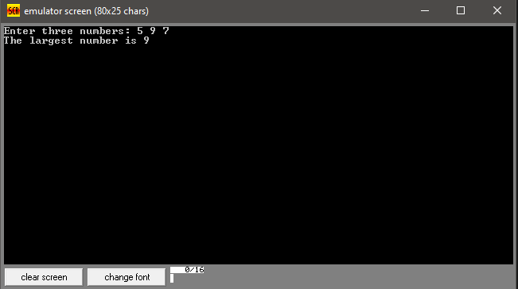

Discussion:

To find largest among three, firstly 3 inputs are taken with a space between them. Then they are compared with their ascii codes and each portion for each case has been performed.